
SOP Title: | eComm STOs SDD Replenishment
Document Storage Location: | STACS/Management/SOPs – Logistics and Warehousing | Document #: | SEASOP431v101
SOP Originator: | Viraj Baraskar | Last Edited by: | Viraj Baraskar
Effective Date: | 05/25/2021 | Last Edited Date: | 05/25/2021
Other:

- Purpose
  - Outlines shipping out stock transfer orders (STO) for warehouses that support same day delivery (SDD) and specifies shipping preparation requirements.
- Scope
  - Coppell – The process that occurs when an STO is systemically dropped to be shipped from the Coppell WH to another SEA facility.
- Responsibilities
  - The Demand Fulfillment (DF) team will drop the STO’s DOs per the forecast and using min/max methodology.
  - 3PL eCommerce (eComm) team physically ships out the orders and processes the order in their WMS system.
  - The SEA Logistics eComm team shall be responsible for completing the necessary GMP transactions, and troubleshooting any issues.
- Instructions
  - DF drops an STO which populates both GMP and the 3PL’s WMS
    - In GMP an outbound delivery order (DO) is created to ship all or part of the STO
      - A delivery order in GMP looks like this
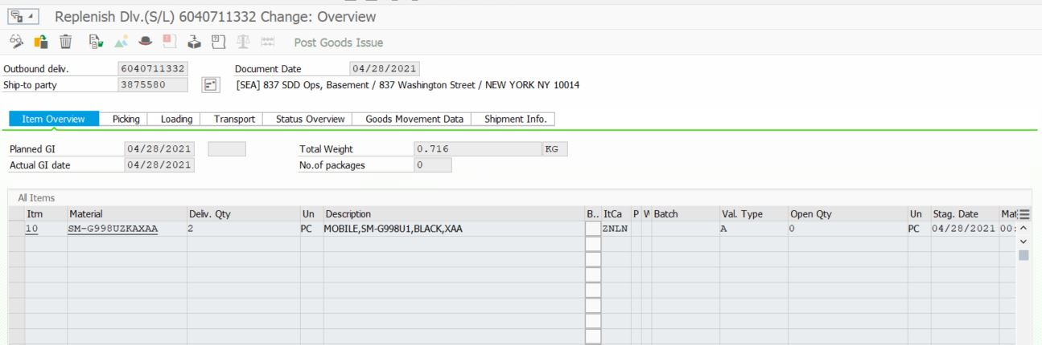
    - The DOs drop as outbound shipment orders in 3PL WMS (since their WMS cannot process STOs).
      - The STO delivery order in 3PL WMS looks like this
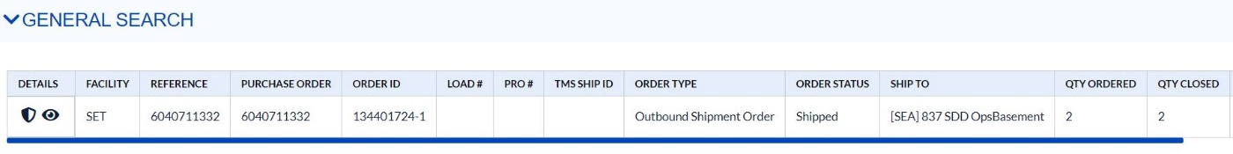

    - These orders drop every week on Wednesdays. Additional orders drop as and when needed.
  - Shipping Preparation:
    - The 3PL team ships the units the same day the orders drop.
      - The orders ship via FedEx 2nd Day Air service level on the express network only.
        - There will be no exceptions to this step.
    - To reduce the risk of theft of the units in transit,
      - Shipping label shall have no reference to content or Samsung
      - Boxes shall have no markings on outside indicating content or Samsung
      - Orders are to ship in full case quantities when possible and Master cartons are to be used when possible
        - All orders will be placed in an overpack
      - Two(2) inch security tape should be used on all cartons and to seal all seams (H-tape)
      - Banding should be added on all cartons
Box Size | Bands / Length | Bands / Width
XXSM & XSM | 1 | 1
SM & MED | 1 | 2
LRG | 2 | 2

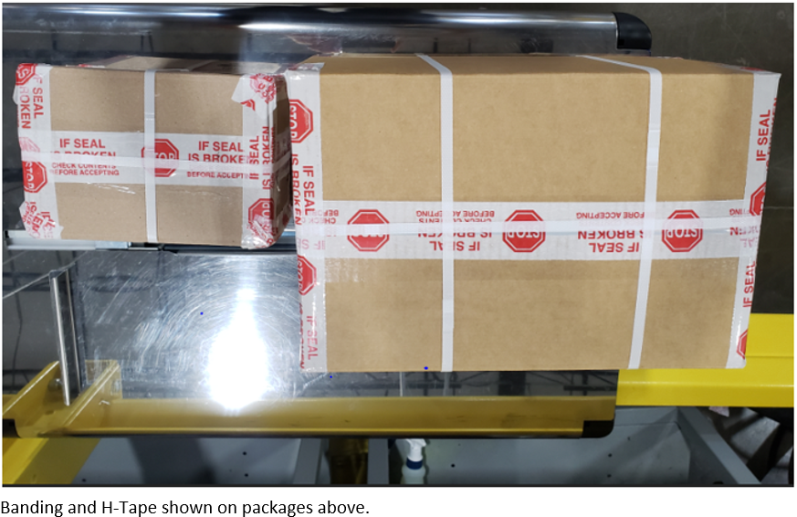

  - GMP: STO Goods Issue
    - The SEA Logistics eComm team will systemically issue the (STO’s) DO in GMP on the same day the 3PL eComm team ships the order
      - Failure to process the same day results in inventory discrepancy on the Stock Comparison Report (SCR) and hence this should be avoided at any cost.
    - The DO can be issued in GMP by the following process:
      - GMP:VL02N
        - Enter the outbound delivery number
        - On next screen, click on the “Post Goods Issue” button as seen below

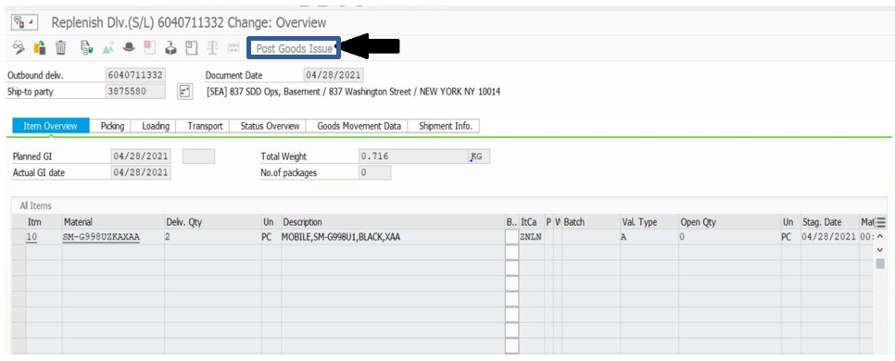
    - Once the DOs are posted in GMP, the receipt will be visible in the 3PL’s WMS and open for the receiving location to systematically receive the order
      - 3PL’s WMS will then show:
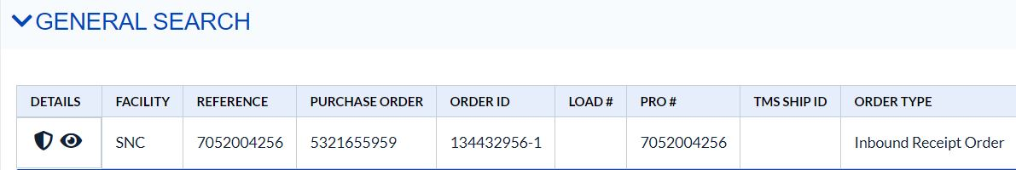
    - Once the receiving location confirms the goods receipt for these units, SEA Logistics GRs the STO in GMP by the following process:
      - GMP: MIGO
        - Select “Goods Receipt” as seen below
        - Select ”Inbound Delivery” as seen below
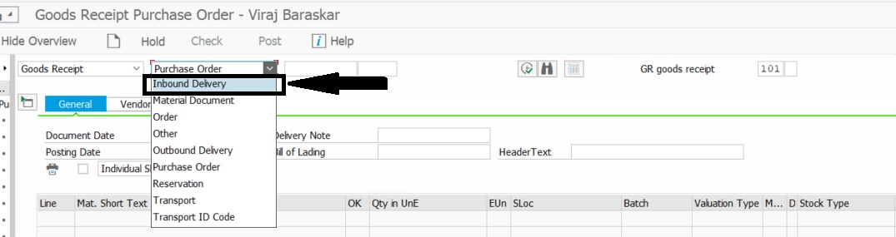
        - Enter the inbound DO
          - Number shows in WMS search above under headings “Pro #” & “Reference”
        - Confirm the unit quantity under “Qty in UnE” column
        - Click on the box beside ‘Item OK’
        - Click on “Post”icon
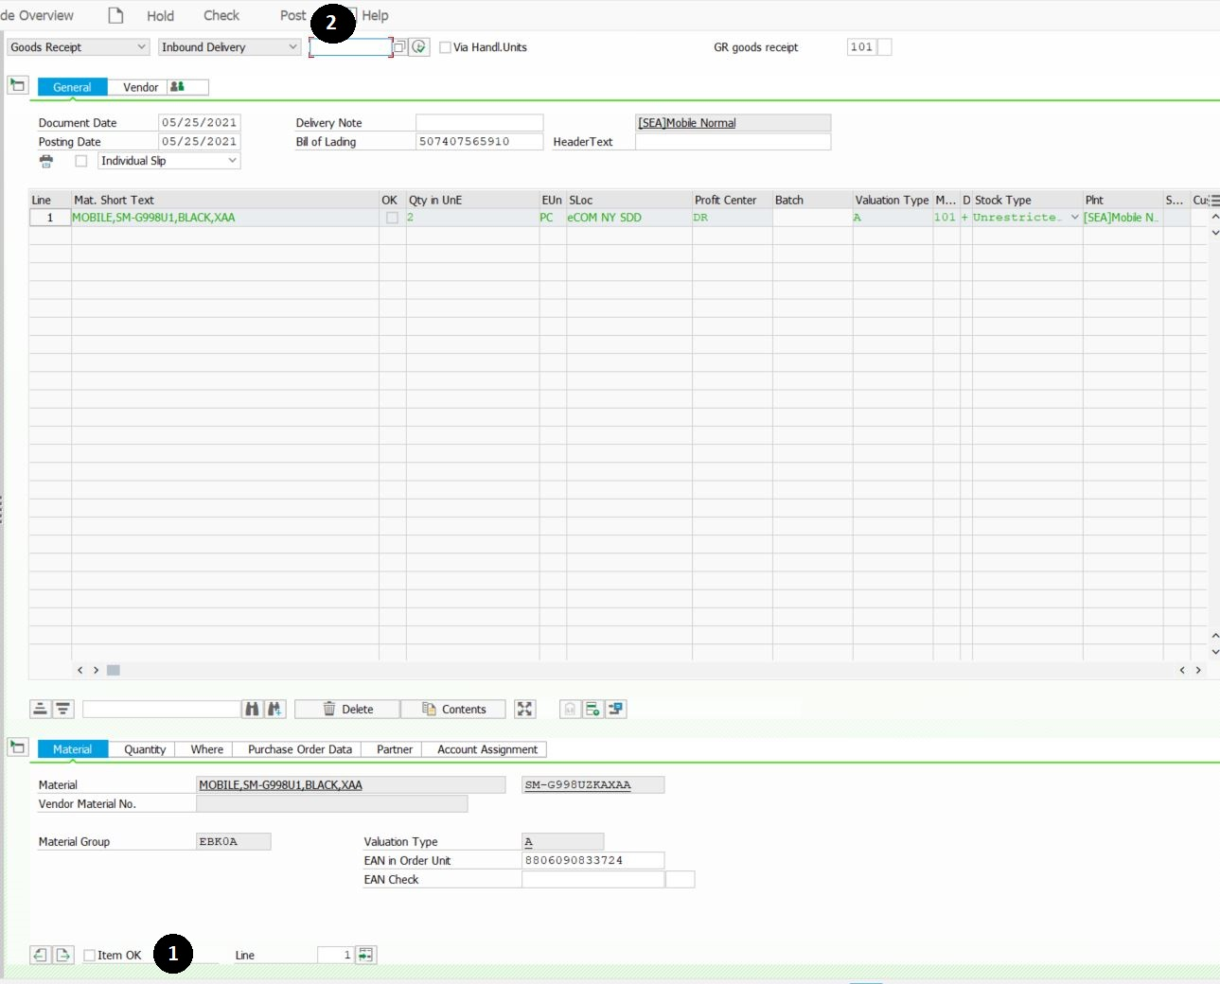
  - Validating Transaction:
    - T-code ZRMMM30510 shows Open STOs
      - DOs pending GR and POs pending drop for balance of units
    - Please reference SOP for this t-code: Open STO Report

- Relevant Documents:
- Revision History:

Revision# | Date Revised | Document # | Revised By | Change Made (Brief)
1 | 06/10/2021 | SEASOP431v101 | Viraj Baraskar | Initial Release
2

